4.2 CSS Classes

Objectives:

At the end of this lesson, you will be able to:
- Use class selectors to create multiple styles for XHTML elements.
- Use the <span> tag to apply class styling to specific words.

Instructions

- Create a new folder called "4.2_CSS Classes".
- Make a copy of the index.html file from the "1.2_Line Breaks" folder and save it into the "4.2_CSS Classes" folder.
- Open and begin editing the index.html file you just pasted into 4.2_CSS Classes.
- Change the title to be "CSS Classes".
- Create a CSS class called "headline" that makes text centered and blue. Apply the class to the <h1> element.
- Add CSS code to make all <h2> tags centered on the screen.
- Create a CSS class called "place-description" and make it display in the Verdana font and in brown color. Apply the class to the paragraph element in the "place I would like to visit" section of your web page.
- Create a CSS class called "person-description" and make it display in purple color. Apply the class to the paragraph element in the "person I admire" section of your web page.
- Create a CSS class called "most-favorite" that applies only to the <li> element. Make the class display text in bold red letters. Apply the class to one of the items in the "favorite fruits" list.
- Create a CSS class called "important-point" and make it display text as underlined. In the "person I admire" section, choose one sentence or portion of a sentence and apply the "important-point" class to it by using the <span> element.
- HINT see the sample of a span in use in this code 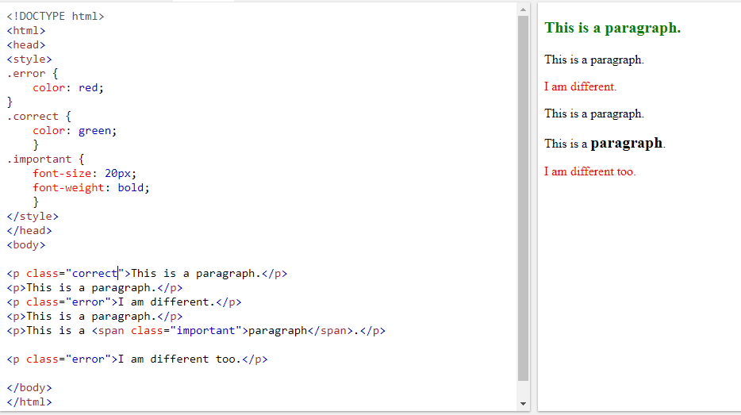
- Save the file.
- In a web browser, open both the original index.html file (from the "Line Breaks" folder) and the index.html file you just saved containing the CSS styling.
- Compare the two web pages and notice the different formatting your CSS code created.

When You are FINISHED, and if you are ahead of the class and not trying to catch up on assignments, Do the following:
  - Make a copy of the the 2.2_PhotoGallery folder and rename the Copy of the folder “4.4_css_practice”
  - Change the index title to CSS Practice
  - Add CSS to the head section of the index.
  - Then go to https://www.w3schools.com/css/default.asp and scroll down to look at the list of Advanced CSS options in the left hand menu.
  - Add rounded corners to all your images.
  - Make the links at the bottom of all the sub-pages into buttons.
  - Add shadows to All h1’s at the top of the page – be creative – play around with the different types.
  - Change the fonts of all your headings to be sans serif.
  - Add shadows to all the images. Play around and see how they change with different values.

Rubric: CSS Classes

Name: ____________________________

Component | Possible Points | Score
The <h2> tags are centered without the use of classes. | 3
A "headline" class was correctly created and applied to the <h1> tag. | 3
A "place-description" class was created and applied to the correct paragraph element. | 3
A "person-description" class was created and applied to the correct paragraph element. | 3
A "most-favorite" class was created that only applies to the list item element and one of the list items in the "fruits" section reflects this styling. | 3
An "important-point" class was created and applied correctly to a portion of the "person I admire" paragraph by using the <span> element. | 3
All CSS styling is in the <style> element inside the <head> section and has correct syntax and nesting with no errors. | 5
The project was submitted on time (20% off for each day late)
Total Score | 23

